INTRODUCTION TO COMPUTERS NETWORKS.

(ASSIGNMENT)

**:-**BY SHIVAM ASTHANA

MBA, SEC D, (2313664)

TO

MR. Anurag Pandey

Professor, Information Technologies.

**INFORMATION TECHNOLOGY**

**(KMBN151)**

**ASSIGNMENT 3**

**ON**

**COMPUTER NETWORK**

**NAME:- Shivam Asthana**

**class:- M.B.A sec-D**

**(2313664)**

**ASSIGNMENT SUBMITTED TO:-**

MR. ANURAG PANDEY SIR.

(It professor)

Table of Contents

COMPUTER NETWORK 2

Network and Internet 2

There are mainly five types of Computer Networks 3

Metropolitan Area Network (MAN) 5

Wide Area Network (WAN) 6

Advantages of WAN in Computer Network. 7

What is an IP Address? 8

TELNET 10

Modes of Operation 11

GOPHER 12

URL 13

DOMAIN NAMES 15

What is a Web Browser? 16

How does a Web Browser Work? 16

Client-server model 17

Netiquette: General rules of conduct 18

Netiquette: Safety rules for children 20

## COMPUTER NETWORK

A computer network is a system that connects two or more computing devices for transmitting and sharing information. Computing devices include everything from a mobile phone to a server. These devices are connected using physical wires such as fiber optics, but they can also be wireless. (Mohanakrishan, 2023)

## Network and Internet

A network is a collection of computers, servers, mainframes, network devices, and other devices connected to one another to allow the sharing of data and resources. This connection can be established through various methods such as wired or wireless connections. Networks can be categorized based on their geographical scope, such as LAN1, WAN2, and MAN3.

The internet, on the other hand, is a global network that connects millions of private, public, academic, business, and government networks. It is a massive network infrastructure that connects millions of computers globally, allowing them to communicate and share information. The internet enables communication through a variety of services such as email, web browsing, file transfer, online gaming, and more.

In summary, a network is a collection of interconnected devices, while the internet is a global network that interconnects multiple networks worldwide.

## There are mainly five types of Computer Networks

1. Personal Area Network (PAN)

2. Local Area Network (LAN)

3. Campus Area Network (CAN)

4. Metropolitan Area Network (MAN)

5. Wide Area Network (WAN)

LAN is the most frequently used network. A LAN is a computer network that connects computers through a common communication path, contained within a limited area, that is, locally. A LAN encompasses two or more computers connected over a server. The two important technologies involved in this network are Ethernet4 and Wi-fi5. It ranges up to 2km & transmission speed is very high with easy maintenance and low cost.

Examples of LAN are networking in a home, school, library, laboratory, college, office, etc.

**Advantages of LAN-**

Simple and Inexpensive: The main benefit of the Local Area Network is that it is prompt and easy to set up at a comparatively low price. If an organisation wishes to construct a network at a low price and with flexibility, a Local area network would be an ideal choice.

* Accessible Software: Programs can also be shared on the Local Area Network. Incorporate a single licensed program, and any device can use it on a network.
* Rapid Communication: LAN-interlinked devices transfer files and communicate directly and rapidly based on the LAN model and ethernet cabling installed. They work on 1000 Mbps, 100 Mbps, and 10 Mbps. Gigabit Ethernet technologies are developing quickly. If this technology becomes sophisticated and large-scale production, lower- cost variants will be accessible to the public.
* Association of Client and Server: All the company-related information is kept on a single server. If a client asks for the information, the client can access it seamlessly.

**Disadvantages of LAN**

* Implementation Cost. Even though LAN saves lots of money in terms of resource sharing, the initial cost involved in setting up the network is quite high.
* Policy Violations. Since all the data of the connected computers are stored inside a central server, unauthorized users can view all the browsing history and downloads of all the ...Security. Since it is rather easy to gain access to programs and other types of data, security concerns are a big issue in LAN.
* Maintenance. LAN often faces hardware problems and system failure. Hence, it requires a special administrator to look after these issues.

## Metropolitan Area Network (MAN)

A MAN is larger than a LAN but smaller than a WAN. This is the type of computer network that connects computers over a geographical distance through a shared communication path over a city, town, or metropolitan area. This network mainly uses FDDI6, CDDI, and ATM7 as the technology with a range from 5km to 50km. Its transmission speed is average. It is difficult to maintain and it comes with a high cost.

Examples of MAN are networking in towns, cities, a single large city, a large area within multiple buildings, etc.

**Advantages of MAN Networks**

• In addition to the lower cost of connecting MAN with LAN,

• MAN provides high-efficiency data transmission.

• MAN networks manage data in a central part where all the nodes are connected to devices.

• MAN network data is transmitted quickly, and you can also send emails fast and for free.

**Disadvantages of MAN**

* There is a security problem and configuration due to the maximum number of LANs is connected, and their size is also significant, so it isn’t easy to manage.
* MAN network cannot work on traditional phone copper wire if they install the network on the copper wire then there will be low speed so if we want a high speed we want to set up fiber optics which is of high cost when we set up the first time.
* In MAN, there is a high chance of stealing data by hackers as we compare it to LAN networks, so there is a chance of leaking our data. If we want to secure data, it requires highly trained staff and security tools.

## Wide Area Network (WAN)

WAN is a type of computer network that connects computers over a large geographical distance through a shared communication path. It is not restrained to a single location but extends over many locations. WAN can also be defined as a group of local area networks that communicate with each other with a range above 50km.

Here we use Leased-Line & Dial-up technology. Its transmission speed is very low and it comes with very high maintenance and very high cost.

## Advantages of WAN in Computer Network.

The WAN is used to connect computers in a huge geographical area of 1000

km approx. The company business can be operated around the globe thanks to WAN networks.

• ISP8 uplinks which can help you to connect other branches of your offices.

• The wan is used in online ticket booking, railway reservations, and airline ticket booking.

• The company’s important and sensitive data and information are stored in a centralized system that can be accessed around the globe.

**Disadvantages of WAN in Computer Network**

* The WAN network is a huge network therefore maintaining this kind of network is a herculean task.
* The primary disadvantage of WAN is they are expensive compared to other networks.
* The peripherals and devices require for the initial installation of the WAN setup is too expensive.
* The WAN is a combination of various other technologies, therefore, has many security issues compared to MAN and LAN

**The most common example of WAN is the Internet.**

The Internet is the foremost important tool and the prominent resource that is being used by almost every person across the globe. It connects millions of computers, webpages, websites, and servers. Using the internet we can send emails, photos, videos, and messages to our loved ones. Or in other words, the Internet is a widespread interconnected network of computers and electronic devices(that support Internet)

History of the Internet

The Internet came in the year 1960 with the creation of the first working model called ARPANET. It allowed multiple computers to work on a single network which was their biggest achievement at that time. ARPANET uses packet switching to communicate multiple computer systems under a single network. In October 1969, using ARPANET first message was transferred from one computer to another. After that technology continues to grow.

How Does the Internet Work?

The actual working of the internet takes place with the help of clients and servers. Here the client is a laptop that is directly connected to the internet and servers are the computers connected indirectly to the Internet and they are having all the websites stored in those large computers. These servers are connected to the internet with the help of ISP (Internet Service Providers) and will be identified with the IP address.

## What is an IP Address?

IP Address stands for Internet Protocol Address. Every PC/Local machine is having an IP address and that IP address is provided by the Internet Service Providers (ISPs). These are some sets of rules which govern the flow of data whenever a device is connected to the Internet. It differentiates computers, websites, and routers. Just like human identification cards like Aadhaar cards, Pan cards, or any other unique identification documents. Every laptop and desktop has its own unique IP address for identification. It’s an important part of Internet technology. An IP address is displayed as a set of four-digit like 192.154.3.29. Here each number on the set ranges from 0 to 255. Hence, the total IP address range from 0.0.0.0 to 255.255.255.255.

**There are four different types of IP addresses are available:**

1. Static IP Address

2. Dynamic IP Address

3. Private IP Address

4. Public IP Address

World Wide Web (WWW)

The world wide web is a collection of all the web pages, and web documents that you can see on the Internet by searching their URLs (Uniform Resource Locator) on the Internet. For example, www.geeksforgeeks.org is the URL of the GFG website, and all the content of this site like webpages and all the web documents are stored on the world wide Web. Or in other words, the world wide web is an information retrieval service of the web. It provides users with a huge array of documents that are connected to each other by means of hypertext or hypermedia links. Here, hyperlinks are known as electronic connections that link the related data so that users can easily access the related information hypertext allows the user to pick a word or phrase from text, and using this keyword or word or phrase can access other documents that contain additional information related to that word or keyword or phrase. World wide web is a project which is created by Timothy Berner’s Lee in 1989, for researchers to work together effectively at CERN. It is an organization, named World Wide Web Consortium (W3C), which was developed for further development in the web. (jimishrav, 2023)

FILES TRANSFER PROTOCOL

FTP stands for File transfer protocol.

o FTP is a standard internet protocol provided by TCP/IP used for transmitting the files from one host to another.

o It is mainly used for transferring the web page files from their creator to the computer that acts as a server for other computers on the internet.

o It is also used for downloading the files to computer from other servers.

**Objectives of FTP**

* It provides the sharing of files.
* It is used to encourage the use of remote computer.
* It transfers the data more reliably and efficiently.

## TELNET

TELNET stands for Teletype Network. It is a type of protocol that enables one computer to connect to the local computer. It is used as a standard TCP/IP protocol for virtual terminal service which is provided by ISO. The computer which starts the connection is known as the local computer.

The computer which is being connected to i.e. which accepts the connection known as the remote computer.

During telnet operation, whatever is being performed on the remote computer will be displayed by the local computer. Telnet operates on a client/server principle. The local computer uses a telnet client program and the remote computers use a telnet server program.

## Modes of Operation

Most telnet implementations operate in one of the following three modes:

1. Default mode

2. Character mode

3. Line mode

1. Default Mode: If no other modes are invoked then this mode is used. Echoing is performed in this mode by the client. In this mode, the user types a character and the client echoes the character on the screen but it does not send it until the whole line is completed.

2. Character Mode: Each character typed in this mode is sent by the client to the server. A server in this type of mode normally echoes characters back to be displayed on the client’s screen.

3. Line Mode: Line editing like echoing, character erasing, etc. is done from the client side. The client will send the whole line to the server.

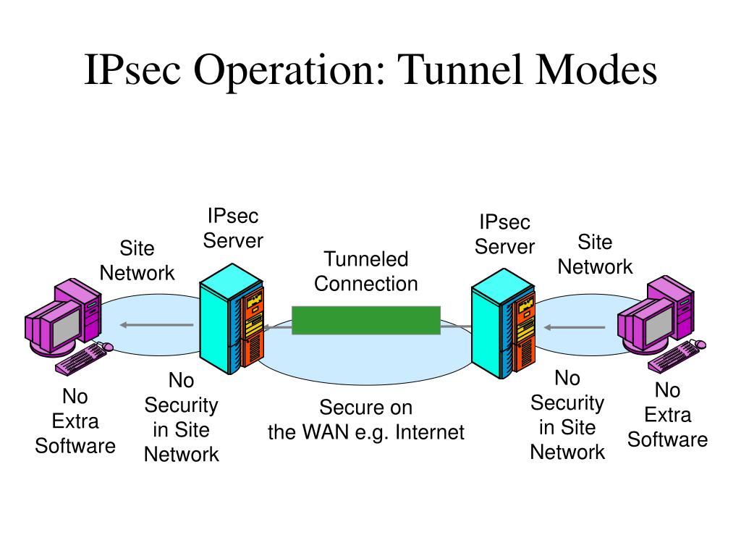

## GOPHER

The Gopher protocol (/ˈɡoʊfər/) is a communication protocol designed for distributing, searching, and retrieving documents in Internet Protocol networks. The design of the Gopher protocol and user interface is menu-driven, and presented an alternative to the World Wide.

Web in its early stages, but ultimately fell into disfavor, yielding to HTTP. The Gopher ecosystem is often regarded as the effective predecessor of the World Wide Web.

The Gopher protocol was invented by a team led by Mark P. McCahill[3] at the University of Minnesota. It offers some features not natively supported by the Web and imposes a much stronger hierarchy on the documents it stores. Its text menu interface is well-suited to computing environments that rely heavily on remote text-oriented computer terminals, which were still common at the time of its creation in 1991, and the simplicity of its protocol facilitated a wide variety Of client implementations. More recent [when?] Gopher revisions and graphical clients added support for multimedia

Item attributes, which can include the items

o Administrator

o Last date of modification

o Different views of the file, like PostScript or plain text, or different languages

o Abstract, or description of the item

• Interactive queries

## URL

URL is the abbreviation of Uniform Resource Locator. It is the resource address on the internet. The URL (Uniform Resource Locator) is created by Tim Berners-Lee and the Internet Engineering working group in 1994. URL is the character string (address) which is used to access data from the internet. The URL is the type of URI (Uniform Resource Identifier).

A URL contains the following information which is listed below:

• Protocol name

• A colon followed by double forward-slash (://)

• Hostname (domain name) or IP address

• A colon followed by port number (optional – unless specified otherwise, “:80” is the default when using HTTP, and “:443” is the default when using HTTPS)

• Path of the file

Protocol: A protocol is the standard set of rules that are used to allow electronic devices to communicate with each other.

Hostname: It describes the name of the server on the network.

Filename: It describes the pathname to the file on the server.

The URL <https://geeksforgeeks.org/php-function> contains the information protocol: https, hostname: geeksforgeeks.org and filename: php-function.

Learn to code easily with our course Coding for Everyone. This course is accessible and designed for everyone, even if you're new to coding. Start today and join millions on a journey to improve your skills!

.

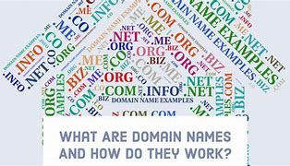

## 

## DOMAIN NAMES

Domain names are the components of a uniform resource locator (URL) that specifically identify a website or web page. They are the part of the URL that comes after the protocol (HTTP or HTTPS) and before the slash that separates the protocol from the rest of the URL. Domain names are used to make websites easily accessible and memorable, and they can help

to establish a website's identity and credibility. There are many different domain name registrars and extension types available, and the rules for registering domain names can vary depending on the county code top-level domain (ccTLD) and other factors.

Domain names are formed by the rules and procedures of the Domain Name System (DNS).

Any name registered in the DNS is a domain name. Domain names are organized in

subordinate levels (subdomains) of the DNS root domain, which is nameless. The first-level set of domain names are the top-level domains (TLDs), including the generic top-level domains (gTLDs), such as the prominent domains com, info, net, edu, and org, and

the country code top-level domains (ccTLDs). Below these top-level domains in the DNS hierarchy are the second-level and third-level domain names that are typically open for

reservation by end-users who wish to connect local area networks to the Internet, create other publicly accessible Internet resources or run web sites.

## What is a Web Browser?

The web browser is an application software to explore www (World Wide Web). It provides an interface between the server and the client and it requests to the server for web documents and services. It works as a compiler to render HTML which is used to design a webpage. Whenever we search for anything on the internet, the browser loads a web page written in HTML, including text, links, images, and other items such as style sheets and JavaScript functions. Google Chrome, Microsoft Edge, Mozilla Firefox, and Safari are examples of web browsers.

## How does a Web Browser Work?

A web browser helps us find information anywhere on the internet. It is installed on the client computer and requests information from the web server such a type of working model is called a client-server model.

## Client-server model

The browser receives information through HTTP protocol. In which transmission of data is defined. When the browser received data from the server, it is rendered in HTML to user- readable form and, information is displayed on the device screen.

**Website Cookies**

When we visited any website over the internet our web browser stores information about us in small files called cookies. Cookies are designed to remember stateful information about our browsing history. Some more cookies are used to remember about us like our interests, our browsing patterns, etc. Websites show us ads based on our interests using cookies.

Some Popular Web Browsers

Here is a list of 7 popular web browsers:

1. Google Chrome:

Developed by Google, Chrome is one of the most widely-used web browsers in the world, known for its speed and simplicity.

2. Mozilla Firefox:

Developed by the Mozilla Foundation, Firefox is an open-source browser that is known for its privacy features and customization options.

3. Apple Safari:

Developed by Apple, Safari is the default browser on Mac and iOS devices and is known for its speed and integration with other Apple products.

4. Microsoft Edge:

Developed by Microsoft, Edge is the default browser on Windows 10 and is known for its integration with other Microsoft products and services.

the rules of conduct for respectful and appropriate communication on the internet. Netiquette is often referred to as etiquette for the internet. These are not legally binding rules, but recommended rules of etiquette. Netiquette is mostly used for dealing with unknown people on the internet. The rules of netiquette very depending on the platform and its participants . Generally, it is up to the operator of a website or communication app to specify the type and scope of netiquette. It is also their responsibility to monitor compliance with these basic rules and to penalize violations of them.

## Netiquette: General rules of conduct

When communicating on the internet, you should always remember that you are communicating with people and not simply with computers or smartphones. As in the real world, rules of etiquette are necessary on the internet. Netiquette is therefore important to avoid adverse consequences.

1.**Stick to the rules of conduct online that you follow in real life**

When communicating online, remember the rules of etiquette that you follow in your everyday life. Refrain from insulting, provoking, threatening or insulting others. Respect the opinions of your chat counterparts and express constructive criticism. Remember that you can be prosecuted for insulting people online.

**2.Netiquette: Think of the person**

Think of the person behind the computer when you compose your messages. You are not communicating with a machine, but with real people. Also, consider what and how you write. Because the internet doesn't forget anything! A screenshot or a copy of your messages is quickly made and still exists even if you delete your messages afterward.

3.**Present your best side online**

Communication on the internet comes with a certain anonymity that does not exist in real life when you are talking to someone face to face. Often this anonymity leads to a

lower inhibition threshold for many users and they behave rudely online if, for example, you disagree with them.

Make sure that you show your best side online. Remain friendly and respectful, even if you disagree. Good netiquette is characterized by respect, politeness and professionalism. ages or individual words entirely in capital letters – even if you want to give these sections more expression. After all, capital letters on the internet mean shouting and are generally considered impolite.

**4**. **Read first, then ask**

Do you have a question about something? Then take the time to carefully read the answers in the previous discussion posts first. There is a good chance that someone has already answered your question. If you write an answer similar to someone else's, it shows the other chat participants that you have paid little attention to the conversation so far.

Remember that conversations online can happen very quickly. It is therefore important to gather all the information before responding or asking questions.

**5.Netiquette:**

Pay attention to grammar and punctuation Take time to read through your answers again. Check them

for grammar, punctuation and correct spelling. It can be very frustrating for the other.

person if they have to decipher poorly written sentences in order grasp the meaning behind them. In addition, faulty grammar distracts from the goal of your message.

## Netiquette: Safety rules for children

The internet is an enrichment for everyone – in everyday life, at school and at work. However, it brings with it some risks and downsides, such as the dark net. Talk to your child and explain the possible risks of the internet. Respect your child's privacy and explain the following rules for children on the internet:

**1.Children on the internet: Do not give out personal information**

In these times of social media, identity theft and social engineering, keeping personal information secret is essential! Under no circumstances should your child share passwords or personal information such as their name, address or telephone number online. The name of the school or clubs should also be kept secret.

**2.Use a neutral nickname** Make sure that your child uses a neutral nickname in chat rooms. This should under no circumstances reveal your child's identity. In addition, a neutral nickname ensures that other people do not feel insulted or ridiculed.

**3.Netiquette and bots/troll posts**

So-called bots are computer programs that usually automatically follow up on a task without requiring any interaction with humans. In social media channels, bots often post comments or even their own posts.

**Bibliography**

GeeksforGeeks. (2023, march 29). Retrieved from www.geeksforgeeks.org: https://www.geeksforgeeks.org/types-of-computer-networks/

jimishrav. (2023, april 25). GeeksforGeeks. Retrieved from www.geeksforgeeks.org:

https://www.geeksforgeeks.org/what-is-internet-definition-uses-working-advantages-and- disadvantages/

kaspersky. (n.d.). Retrieved from www.kaspersky.com: https://www.kaspersky.com/resource- center/preemptive-safety/what-is-netiquette

Mohanakrishan, R. (2023, may 17). spiceworks. Retrieved from www.spiceworks.com:

https://www.spiceworks.com/tech/networking/articles/what-is-a-computer-network/Monday,

SHIVAM ASTHANA

Student, Masters of Business Administrations.

January 22, 2024